**Lab 1**

**Name:** Etcherla Sai Manoj **Mis. No:** 112015044 **Branch:** CSE

**Question1**

**Code:**

#include<iostream>

#include<string>

using namespace std;

class student{

int rollno;

char section;

long long int phone_number;

string name;

public:

void getRollNo(int x){

cin >> rollno;

}

void getName(string x){

cin >> name;

}

void getPhoneNo(long long int x){

cin >> phone_number;

}

void getSection(char x){

cin >> section;

}

void displayStudent(){

cout << "---------------------------------------------" << endl;

cout << "***Details of Student***\n" << endl;

cout << "Roll No.: " << rollno << endl;

cout << "Name : " << name << endl;

cout << "Phone Number : " << phone_number << endl;

cout << "Section : " << section << endl;

cout << "---------------------------------------------" << endl;

}

};

int main(){

student s1;

int x;char y; string n; long long int z;

printf("Enter roll no : ");

s1.getRollNo(x);

printf("Enter your Name : ");

s1.getName(n);

printf("Enter your Phone Number : ");

s1.getPhoneNo(z);

printf("Enter your Section : ");

s1.getSection(y);

s1.displayStudent();

return 0;

}

**Input & Output:**

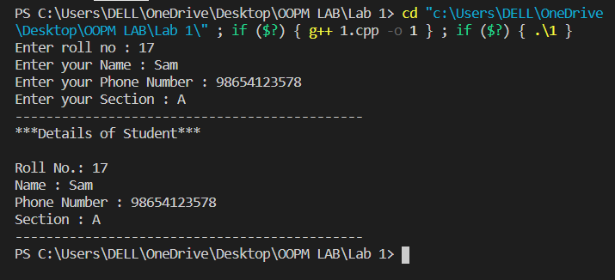

**Question2:**

**Code:**

#include<iostream>

using namespace std;

class sample{

public:

int a;

int b;

};

int main(){

sample s1;

sample *ptr;

ptr = &s1;

ptr->a = 10;

ptr->b = 20;

cout << ptr->a << endl;

cout << ptr->b << endl;

return 0;

}

**Output:**

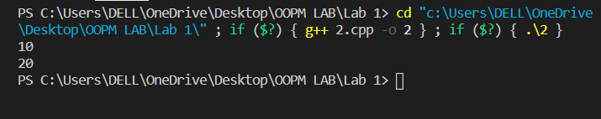

**Question3:**

**Code:**

#include<iostream>

using namespace std;

class Matrix

{

public:

int matrix[5], sum = 0;

int insertValue(){

cout << "Enter elements of Matrix : ";

for(int i = 0; i < 5; i++){

cin >> matrix[i];

}

return 0;

}

int searchElement(int x){

cout << "Enter Element : ";

cin >> x;

for(int i = 0; i < 5; i++){

if(x == matrix[i]){

cout << "Index of element : " << i << endl;

return 0;

}

}

cout << "Not Found" << endl;

return 0;

}

int addAllElements(){

for(int i = 0; i < 5; i++){

sum += matrix[i];

}

cout << "Total sum of Elements in Matrix : " << sum;

return 0;

}

};

int main(){

Matrix m1;

int x;

m1.insertValue();

m1.searchElement(x);

m1.addAllElements();

return 0;

}

**Input & Output:**

*TWO OUTPUTS; ONE IS ELEMENT FOUND IN MATRIX AND ANOTHER ONE IS ELEMENT NOT FOUND IN MATRIX

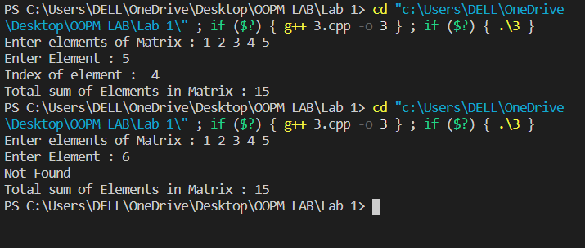

**Question4:**

**Code:**

#include<iostream>

using namespace std;

class Sum

{

public:

int No1, No2;

void printSum(){

cout << "The sum of two nubers is : " << No1 + No2;

}

void printAvg(){

cout << "\nThe average of two numbers is : " << (No1 + No2)/2.0;

}

};

int main(){

Sum s1;

s1.No1 = 53;

s1.No2 = 120;

s1.printSum();

s1.printAvg();

return 0;

}

**Input & Output:**

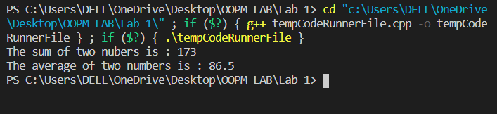

**Question5:**

**Code:**

#include<iostream>

using namespace std;

class sample{

int count = 0;

public:

void countfunction(){

count++;

}

void printcount(){

cout << "Number of times the function called : " << count;

}

};

int main(){

sample s1;

s1.countfunction();

s1.countfunction();

s1.countfunction();

s1.countfunction();

s1.countfunction();

s1.countfunction();

s1.countfunction();

s1.countfunction();

s1.printcount();

return 0;

}

**Input & Output:**

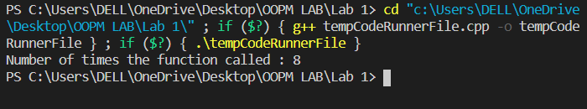

**Question6:**

**Code:**

#include <iostream>

#include<string>

using namespace std;

class Library

{

int id[10],price[10],pages[10],status[10],i,id1,id2,t;

string name[10],author[10],genre[10];

public:

Library()

{

i=0;

}

void withdrawBook(){

cout<<"\nEnter the book id: ";

cin>>id1;

for(t=0;id[t]!='\0';t++){

if(id[t]==id1)

status[i]=2;

}

}

void addBook(){

cout<<"Enter book ID: ";

cin>>id[i];

cout<<"Enter the name of the book: ";

cin>>name[i];

cout<<"Enter the name of the author: ";

cin>>author[i];

cout<<"1 for Available or 2 for Unavailable: ";

cin>>status[i];

cout<<"Enter the genre: ";

cin>>genre[i];

cout<<"Enter the price: ";

cin>>price[i];

cout<<"Enter the number of pages: ";

cin>>pages[i];

}

void searchBook(){

cout<<"\nEnter the book id: ";

cin>>id2;

for(t=0;id[t]!='\0';t++){

if(id[t]==id1){

cout<<"\nBook name: "<<name[i]<<" Aurhor name: "<<author[i];

cout<<" Price: "<<price[i]<<"\nGenre: "<<genre[i]<<" Page count: "<<pages[i];

if(status[i]==2)

cout<<"\n Book unavailable";

else

cout<<"\n Book available";

}

}

}

};

int main()

{

Library L;

int choice, u;

cout << "1. Withdraw a Book" << endl;

cout << "2. Add a Book" << endl;

cout << "3. Search a Book" << endl;

cout << "4. Exit" << endl;

cout << "Select a Choice from above : " << endl;

do

{

cin>>choice;

switch(choice)

{

case 1:

L.withdrawBook();

break;

case 2:

L.addBook();

break;

case 3:

L.searchBook();

break;

}

cout<<"\nEnter 4 to exit or Continue with your choice : ";

}while(choice!=4);

return 0;

}

**Input & Output:**

